Technical Architecture for AI Nutrition

Nasui Elisa
Singh Parisdeep

Main architecture:
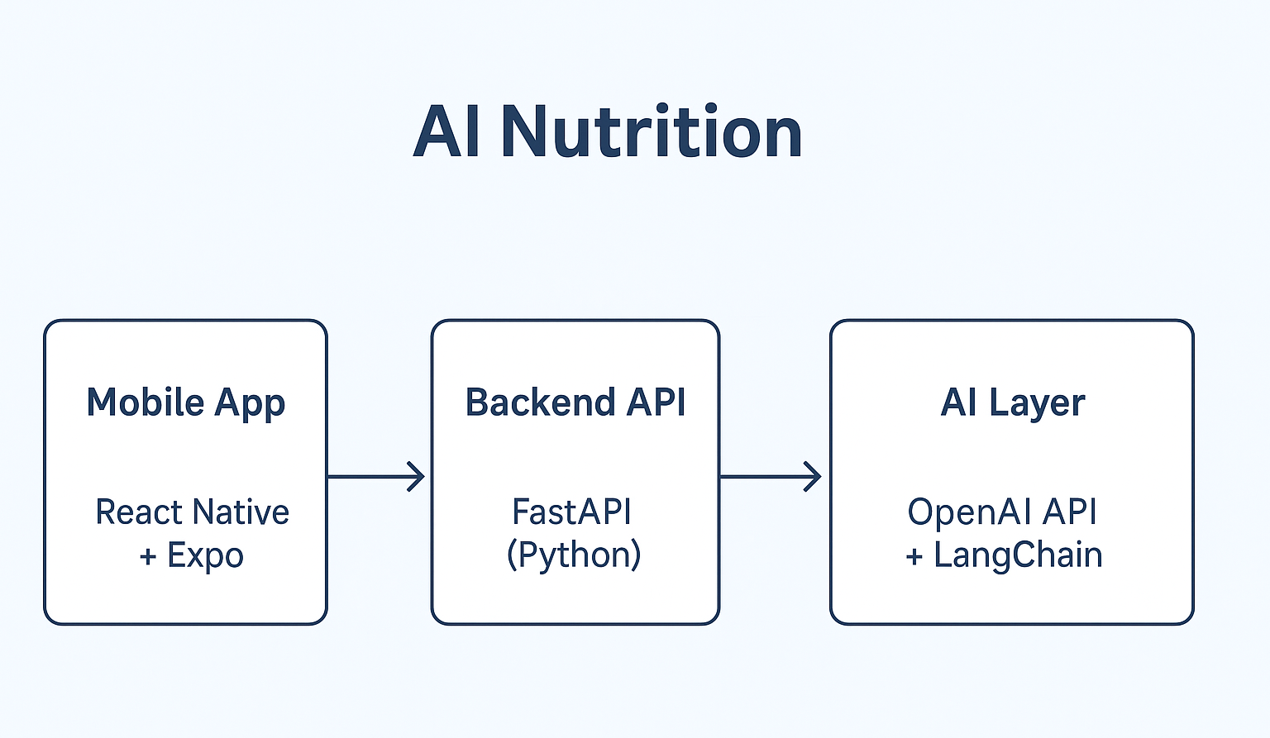

1. General Architecture
[Frontend (React Native + Expo)]
↓
[Backend (flask)]
↓
[AI Layer (OpenAI API )]
↓
[Database (PostgreSQL )]

2. Frontend Framework: React Native + Expo
Interface features:
• Chat interface (Q&A with AI)
• User profile (nutritional information)
• Conversation history
• “Suggestions” section
• Daily push notifications
Expo is a tool that greatly simplifies React Native:
• It allows you to easily test the app on your phone
• It manages permissions (camera, notifications, etc.)
• It allows easy publishing on the Play Store / App Store (even if not needed immediately)
flask
Possible integration with a chat-like UI (libraries such as react-native-gifted-chat) — it’s a message interface similar to WhatsApp.
One single codebase for both iOS and Android.

3. Backend : Flask (Python)

4. Artificial Intelligence
OpenAI API (GPT-4 or GPT-4o-mini) for text generation.
How it works:
- The user sends a question.
- The backend builds a prompt:
-role = nutrition coach
-context = scientific documents + user profile
- GPT-4 generates a structured and reliable answer.
Possibility to add RAG (Retrieval-Augmented Generation) to answer only from validated sources.

5. Database: PostgreSQL
• Robust, free, open-source relational database.
• Stores:
-User profiles
-Conversation history
-Feedback (useful/not useful)
-Meal information

6. Security & Compliance
Authentication via JWT tokens
Encrypted personal data (user profiles)
GDPR compliance: no sensitive data sent to OpenAI without consent
Minimal storage of conversations (anonymized)

7. Stack Summary
Layer | Technology | Explanation
Frontend | React Native + Expo | Multi-platform, smooth UI
Backend | Flask (python) | ……
AI Layer | OpenAI API | Natural and reliable answers
Database | PostgreSQL | Structured data + performance
Auth | JWT | Secure and standard

Example of User Flow
- The user opens the app and logs in.
- They type: “What should I eat after working out?”
- Flask → sends the request to GPT-4 with internal documents.
- The AI returns a personalized response based on their profile.
- The user rates the answer (useful/not useful).
- The data is stored in PostgreSQL for continuous improvement.

